Directions to Washington Park:
Drive West on Highway 20 toward Anacortes and the San Juan ferry terminal. Follow North along Commercial Avenue, turn L onto 12th Street and proceed West for approximately 3 miles. 12th Street will turn into Oakes Avenue, then Sunset Avenue but continue straight and the road will lead you into Washington Park. Also, see the map at the end of this document
Directions to Burrows Pass Parking lot:
Note: Washington Park is open from 6 am to dusk. The loop road is open to walkers at 6 am, but does not open to cars until 10 am.
Driving: Enter the Washington Park Loop Road and drive approximately 1.5 miles to the Burrows Pass lot. There is a parking area on your right atop some high bluffs, and you will see “Burrows Pass Preservation Area” signs. This drive takes 5-10 minutes due to the slow speed required.
Walking: Walk from the exit of the loop road up the hill approximately 0.5 miles to the Burrows Pass parking lot, which will now be on your left. This walk talks about 8-10 minutes.
Directions to observation site at Burrows Pass:
From the Burrows Pass Parking lot in Washington Park, walk past the “Burrows Pass Preservation Area” sign at the left and follow the trail between the fence posts. At the signpost with the orange line, stay to your right. At the signpost with red and lavender lines, stay to your left. In about 15 yards, you will come to an area where the trail broadens out to some rocks on your left. Instead of following the trail down the bluff, turn to your left and descend another 5 yards onto some rock steps. Stop here. If you turn around and look uphill, you should be able to see a bit of the fence, the 2 trail signposts you passed, and the back of the big “Burrows Pass Preservation” sign. Good, you are in the right place! Make yourself comfortable and orient yourself to the observation area in Burrows Pass. Please be sure to stay on the rocks in order to avoid damaging the fragile meadows.

Washington Park website:
http://www.cityofanacortes.org/Parks/WaPark/wa_park.htm
Map of the Park
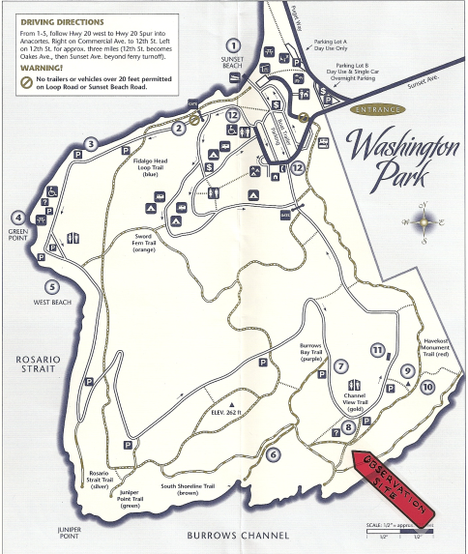

This is a beautiful park. Save some time to hike the trails described below. Juniper Point at the SW corner of the park is another spectacular view where you might see porpoise.

